Model of path: Light hits from the sun perpendicularly at the ozone layer

The sun will be modeled as a yellow hydrogen fusion star

Produces 3.8*10^33 ergs/second

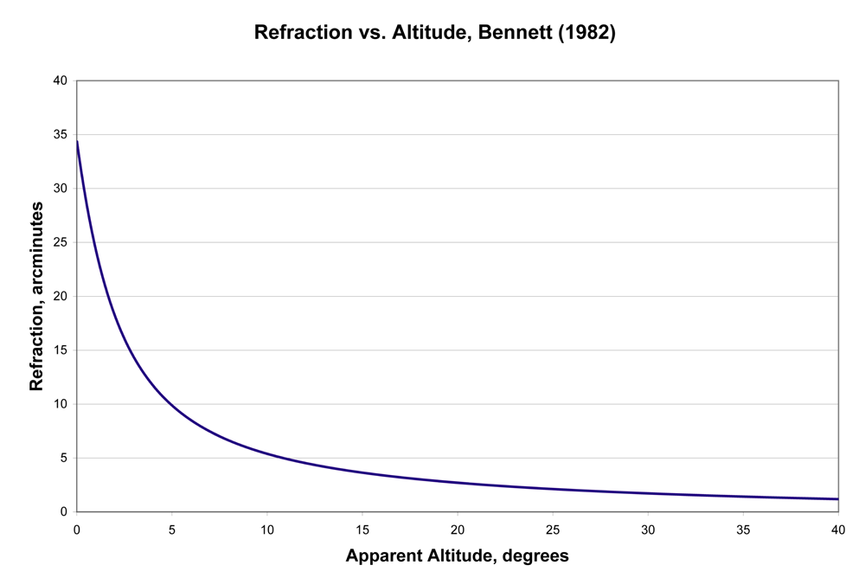

Comstock’s equation

R=(n_0-1)cot(h_a) R is refraction in radians n_0 is the index of refraction at the observer and h_a is the apparent altitude of the astronomical body

U.S. Naval Observatory uses

R=1.02cot(h+(10.3/(h+5.11)))

Refraction increses 1% for every 0.9 kPa increase

House

Solar panel

Inner atmosphere

Outer atmosphere

Sun